EX NO: 7 | CALCULATION AND VERIFICATION OF FREQUENCY DEVIATION AND MODULATION INDEX OF FM SIGNALS USING MATLAB SIMULATION
DATE:

Objectives:
1. To generate a Frequency Modulated (FM) signal in MATLAB using specified carrier and message signal parameters.
2. To calculate and verify the frequency deviation of the FM signal from the given carrier frequency and modulating signal parameters.
3. To determine and verify the modulation index of the FM signal using the relationship between frequency deviation and message frequency.
4. To analyze the effect of message frequency on frequency deviation and modulation index, and verify their relationship through MATLAB simulation
Procedure
1. Open MATLAB and create a new script file.
2. Clear the command window, workspace variables, and close all previously opened figure windows using:
Clc;
Clear;
close all;
3. Define the message signal parameters:
● Message amplitude A_m=2V
● Message frequency f_m=500Hz
4. Define the carrier signal parameters:
● Carrier amplitude A_c=1V
● Carrier frequency f_c=10000Hz
5. Define the frequency sensitivity constant k_f, sampling frequency f_s, and simulation duration T
6. Generate the time vector using:
t = 0:1/fs:T;
7. Generate the message signal using:
m = Am*cos(2*pi*fm*t);
and observe the sinusoidal waveform.
8. Calculate the frequency deviation of the FM signal using:
Δf=kf. Am
9. Calculate the modulation index using:
β=Δf/fm
10. Generate the FM signal using:
fm_signal = Ac*cos(2*pi*fc*t + beta*sin(2*pi*fm*t));
where the carrier frequency varies according to the message signal.
11. Plot the message signal in the first subplot and label the axes appropriately. 12. Plot the FM signal in the second subplot and observe the variation in instantaneous frequency.
13. Display the carrier frequency, message frequency, message amplitude, and frequency sensitivity in the MATLAB command window using fprintf statements.
14. Display the calculated frequency deviation and modulation index values in the command window.
15. Verify the modulation index by recomputing it using:
β=Δf/fm
and compare the result with the previously calculated value.
16. Use a conditional statement (if-else) to check whether both modulation index values are equal within a small tolerance.
17. Display the verification result as:
● "Verification Successful" if both values match.
● "Verification Failed" otherwise.
18. Execute the MATLAB program and observe the message signal, FM signal, calculated frequency deviation, modulation index, and verification result.
PROGRAM (MATLAB CODE)
OBJECTIVE1:
%% EXP 7 - Objective 1: FM Signal Generation
clc;
clear;
close all;

% Given Parameters
Am = 2; % Message amplitude (V)
fm = 500; % Message frequency (Hz)
Ac = 1; % Carrier amplitude (V)
fc = 10000; % Carrier frequency (Hz)
kf = 250; % Frequency sensitivity (Hz/V)
fs = 100000; % Sampling frequency (Hz)
T = 0.01; % Simulation duration (s)

% Time Vector
t = 0:1/fs:T;

% Modulating and Carrier Signals
m = Am * cos(2 * pi * fm * t);
c = Ac * cos(2 * pi * fc * t);

% FM Modulation
delta_f = kf * Am;
beta = delta_f / fm;
fm_signal = Ac * cos(2 * pi * fc * t + beta * sin(2 * pi * fm * t));

% Plot Time-Domain Waveforms
figure('Name', 'Objective 1: FM Signal Generation', 'NumberTitle', 'off');

subplot(3,1,1);
plot(t, m, 'b', 'LineWidth', 1.5);
title('1. Message Signal m(t)');
xlabel('Time (s)'); ylabel('Amplitude (V)');
grid on;

subplot(3,1,2);
plot(t, c, 'k', 'LineWidth', 1);
title('2. Unmodulated Carrier Signal c(t)');
xlabel('Time (s)'); ylabel('Amplitude (V)');
grid on;

subplot(3,1,3);
plot(t, fm_signal, 'r', 'LineWidth', 1);
title('3. Frequency Modulated (FM) Signal');
xlabel('Time (s)'); ylabel('Amplitude (V)');
grid on;
OBJECTIVE2:
%% EXP 7 - Objective 2: Calculation and Verification of Frequency Deviation
clc;
clear;
close all;

% Parameters
Am = 2; % Message amplitude (V)
fc = 10000; % Carrier frequency (Hz)
kf = 250; % Frequency sensitivity (Hz/V)

% Frequency Deviation Calculation
delta_f = kf * Am;
f_max = fc + delta_f;
f_min = fc - delta_f;
delta_f_measured = (f_max - f_min) / 2;

% Display Verification
fprintf('--- Objective 2: Frequency Deviation Verification ---\n');
fprintf('Frequency Sensitivity (kf) : %.0f Hz/V\n', kf);
fprintf('Message Amplitude (Am) : %.0f V\n', Am);
fprintf('Calculated Peak Deviation (Af) : %.2f Hz\n', delta_f);
fprintf('Maximum Instantaneous Freq : %.2f Hz\n', f_max);
fprintf('Minimum Instantaneous Freq : %.2f Hz\n', f_min);
fprintf('Verified Peak Deviation : %.2f Hz\n', delta_f_measured);

if abs(delta_f - delta_f_measured) < 1e-6
fprintf('Status: Frequency Deviation Verification Successful\n');
else
fprintf('Status: Frequency Deviation Verification Failed\n');
end
OBJECTIVE3:
%% EXP 7 - Objective 3: Modulation Index Determination & Verification
clc;
clear;
close all;

% Given Parameters
Am = 2;
fm = 500;
Ac = 1;
fc = 10000;
kf = 250;

% Calculations
delta_f = kf * Am;
beta = delta_f / fm;
beta_verify = delta_f / fm;

% Display Formatted Verification Table
fprintf('--- Objective 3: Modulation Index Verification ---\n');
fprintf('Carrier Frequency (fc) = %.0f Hz\n', fc);
fprintf('Message Frequency (fm) = %.0f Hz\n', fm);
fprintf('Message Amplitude (Am) = %.0f V\n', Am);
fprintf('Frequency Sensitivity (kf) = %.0f Hz/V\n', kf);
fprintf('Frequency Deviation (Delta f)= %.2f Hz\n', delta_f);
fprintf('Modulation Index (Beta) = %.2f\n', beta);
fprintf('Verified Modulation Index = %.2f\n', beta_verify);

% Verification Check
tolerance = 1e-6;
if abs(beta - beta_verify) < tolerance
fprintf('\nVerification Successful\n');
else
fprintf('\nVerification Failed\n');
end
OBJECTIVE4:
-%% EXP 7 - Objective 4: Effect of fm on Frequency Deviation and Beta
clc;
clear;
close all;

% Fixed Modulator Settings
Am = 2; % Message amplitude (V)
kf = 250; % Frequency sensitivity (Hz/V)
delta_f_const = kf * Am; % Peak deviation remains constant (500 Hz)

% Test Across Different Message Frequencies
fm_range = [100, 250, 500, 1000, 2000]; % Frequencies in Hz
beta_vals = delta_f_const ./ fm_range;
delta_f_vals = repmat(delta_f_const, size(fm_range));

% Tabular Output to Console
fprintf('--- Objective 4: Invariance of Delta_f and Inverse Scaling of Beta ---\n');
fprintf(' fm (Hz) | Delta_f (Hz) | Beta (m_f) \n');
fprintf('--------------------------------------------\n');
for i = 1:length(fm_range)
fprintf(' %4d | %6.2f | %6.2f \n', fm_range(i), delta_f_vals(i), beta_vals(i));
end

% Plotting the Relationships
figure('Name', 'Objective 4: Sensitivity to Message Frequency', 'NumberTitle', 'off');

subplot(2,1,1);
plot(fm_range, delta_f_vals, '-s', 'LineWidth', 1.5, 'MarkerFaceColor', 'r');
title('Peak Frequency Deviation (\Delta f) vs. Message Frequency (f_m)');
xlabel('Message Frequency f_m (Hz)'); ylabel('\Delta f (Hz)');
ylim([0, delta_f_const * 1.5]);
grid on;

subplot(2,1,2);
plot(fm_range, beta_vals, '-o', 'LineWidth', 1.5, 'MarkerFaceColor', 'b');
title('Modulation Index (\beta) vs. Message Frequency (f_m)');
xlabel('Message Frequency f_m (Hz)'); ylabel('Modulation Index \beta');
grid on;
OUTPUT:
O1:
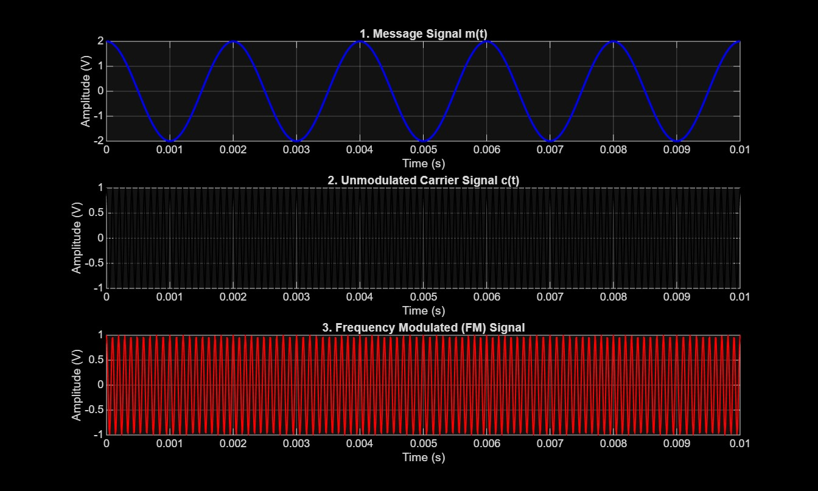
O2:
--- Objective 2: Frequency Deviation Verification ---
Frequency Sensitivity (kf) : 250 Hz/V
Message Amplitude (Am) : 2 V
Calculated Peak Deviation (Af) : 500.00 Hz
Maximum Instantaneous Freq : 10500.00 Hz
Minimum Instantaneous Freq : 9500.00 Hz
Verified Peak Deviation : 500.00 Hz
Status: Frequency Deviation Verification Successful
O3:
--- Objective 3: Modulation Index Verification ---
Carrier Frequency (fc) = 10000 Hz
Message Frequency (fm) = 500 Hz
Message Amplitude (Am) = 2 V
Frequency Sensitivity (kf) = 250 Hz/V
Frequency Deviation (Delta f)= 500.00 Hz
Modulation Index (Beta) = 1.00
Verified Modulation Index = 1.00
O4:
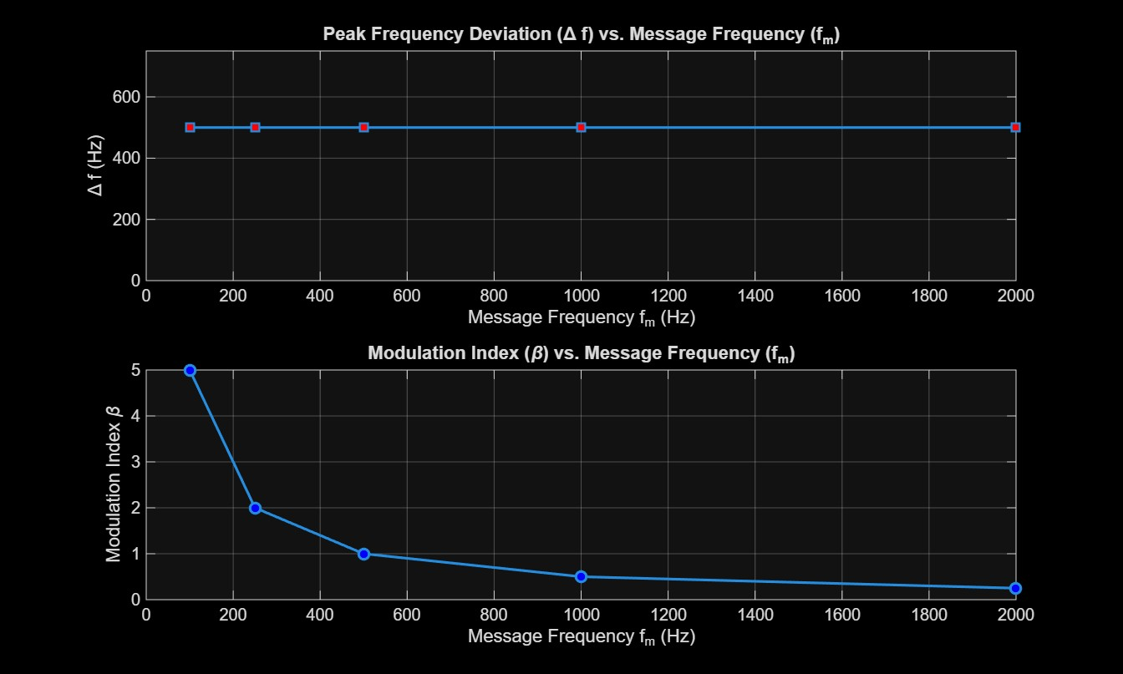
--- Objective 4: Invariance of Delta_f and Inverse Scaling of Beta ---
fm (Hz) | Delta_f (Hz) | Beta (m_f)
--------------------------------------------
100 | 500.00 | 5.00
250 | 500.00 | 2.00
500 | 500.00 | 1.00
1000 | 500.00 | 0.50
2000 | 500.00 | 0.25
RESULT:
1. Generate and visualize carrier, message, and FM signals using MATLAB.
2. Calculate the theoretical frequency deviation and verify it from the simulated FM waveform. 3. Calculate the FM modulation index and verify the relationship β = Δf/fm.
4. Interpret the effect of changing message frequency on modulation index and verify that, for constant frequency sensitivity and message amplitude, the peak frequency deviation remains constant.

